NAME: _____________________

CLASS: ______________________

Home Booklet
Fun Music Activities
to do at Home

Music Challenges
Choose at least 2 challenges a week. Colour in the block when it is completed. Have fun creating music! I miss you and can’t wait to play instruments in the library with you soon.
M | U | S | I | C
Teach someone in your family a song or activity that you have learned in music class | Interview a family member about their favourite song and listen to it together | Design and draw a new instrument. Explain how it would be played | Make an instrument out of household items and play along to your favourite songs | Write 5 rhythm patterns and say, play and teach them to another family member
Take a listening walk (inside or outside) and list all of the sounds you hear | Write about and draw a picture of your favourite musician | Watch your favourite tv show or movie and write about how music enhanced the show | Listen to the Triple J radio station. Write down the songs you hear. | Watch a musical with your family and write about and draw your favourite scene
Talk to a family member about your favourite musical memory | Listen to a song and draw how it makes you feel |  | Dance or move to the beat of your favourite song | Ask a family member to play an instrument or sing to you
Talk to a family member about their favourite musical memory | Write a parody song (change the words to a song that already exists) | Listen to the ABC radio station. Write down the songs you hear. | Plan a karaoke party for your family and enjoy singing together | Give a music recital for your family. Play your instrument or sing a song!
Who is your favourite composer?  Write 5 musical facts about the composer and draw a picture | Choreograph a dance to a song and perform it for someone else | Watch a (parental approved) musical concert on YouTube and write a review | Read a music related book, story or article. Tell a friend about tit. | Write what music means to you.

Notes for the Music Challenges

Notes for the Music Challenges

Colouring in Pages

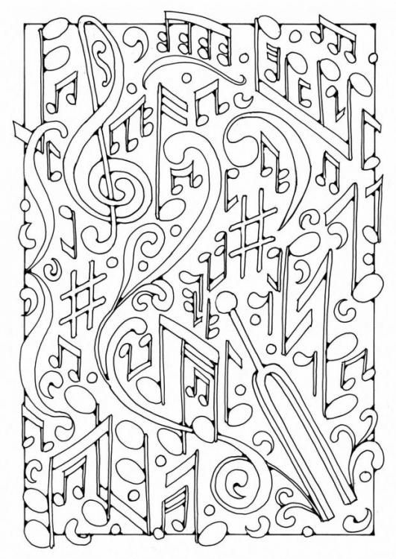

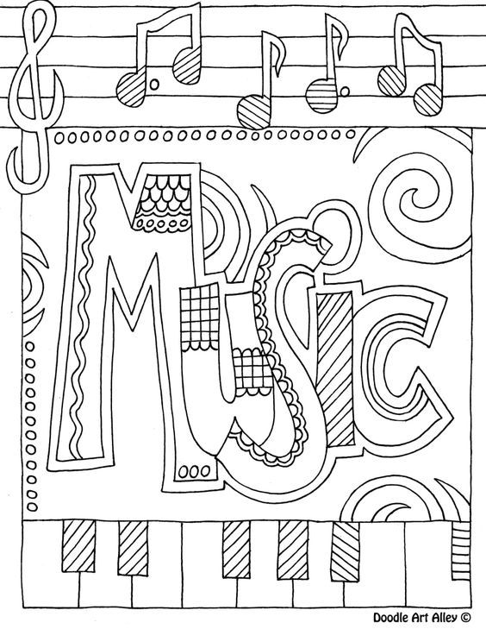

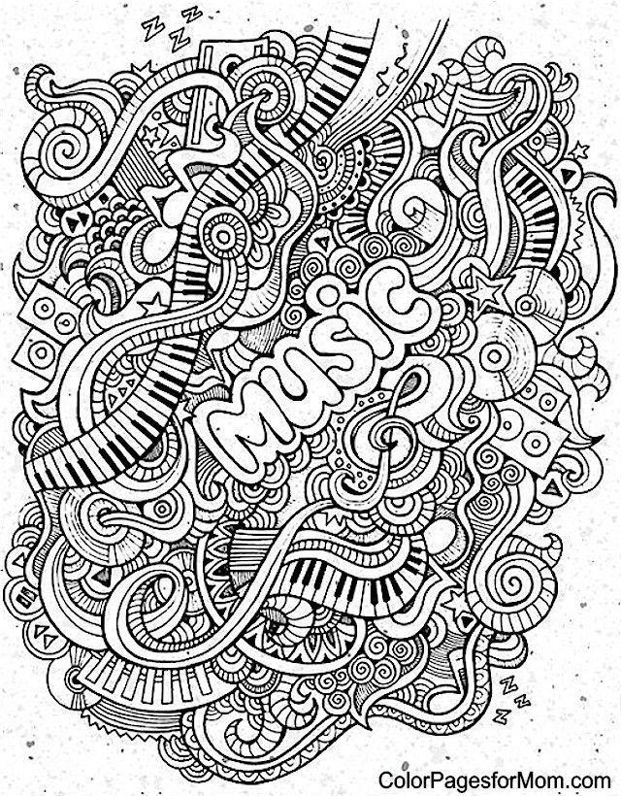
Music Scavenger Hunt
Directions: Find the following items around your home.

Find something that…

- Makes a HIGH sound
- Makes a LOW sound
- Makes a LOUD sound
- Makes a SOFT sound
- Moves FAST
- Moves SLOW
- You can SHAKE to make a sound
- You can SCRAPE or RUB to make a sound
- You can tap that is made out of METAL
- You can tap that is made out of WOOD

Draw, or take photos of your findings. Add them to the next page.
Record a video of you playing the items you found.

Create a song that uses the items!
Be as creative as you want.

Music Scavenger Hunt Results Directions: Draw or put photos of your results here

Music Scavenger Hunt
Write down notes about your song here. Then teach it to your family.

